Password List

|  |  |  |
| --- | --- | --- |
| Password | Components | Strength |
| krish123 | Lowercase + Numbers | Weak – short and predictable |
| Krish@123 | Uppercase + Lowercase + Numbers + Symbol | Medium – better, but still common pattern |
| K!r8h$29Yq | Mixed case + Symbols + Numbers | Strong – random and complex |
| >rM,6$Ai?p4 | Fully random, 12 characters | Very Strong – secure against brute-force |

Test on passwordmeter.com

* krish123

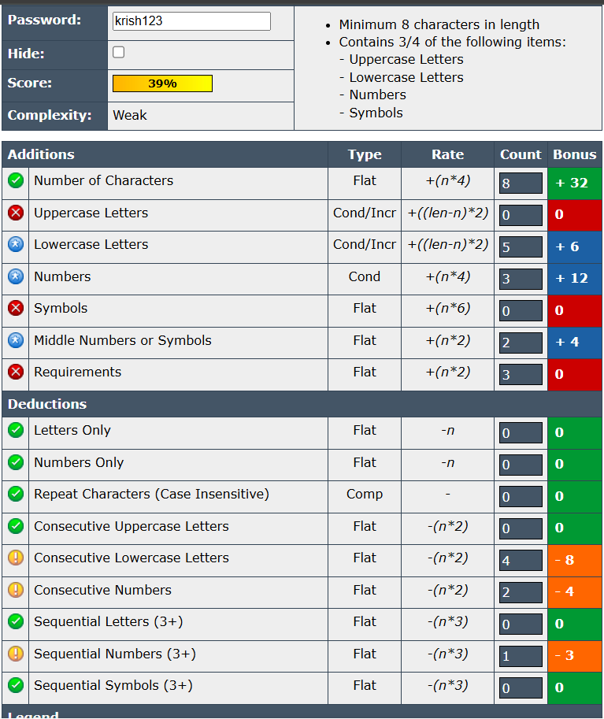

* Krish@123

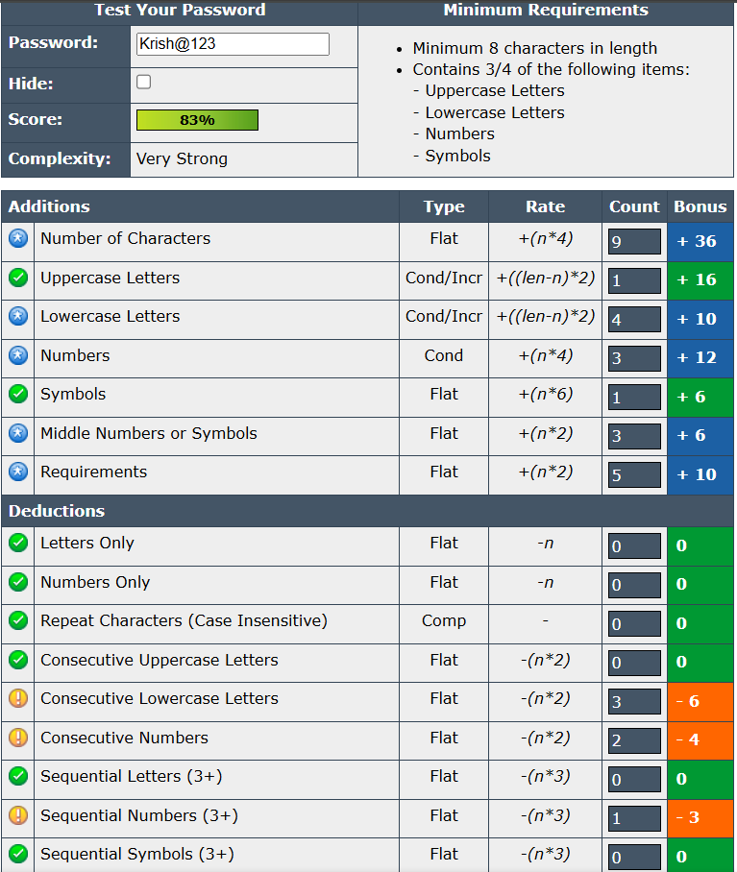

* K!r8h$29Yq

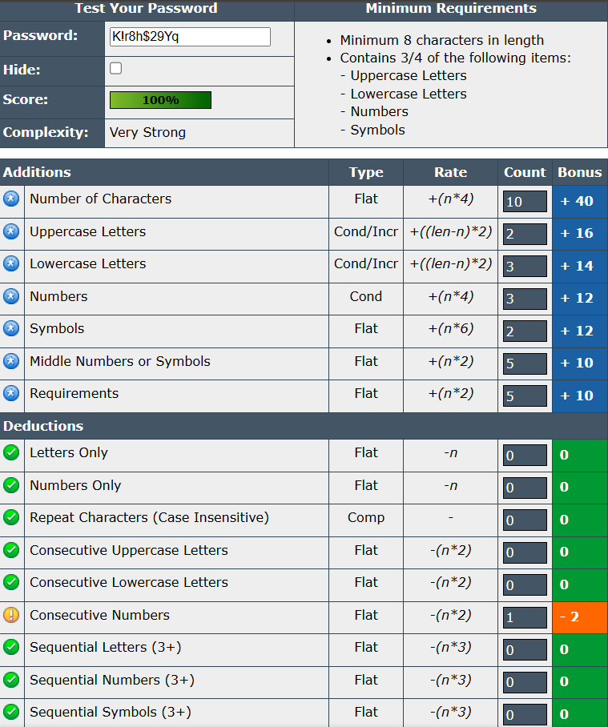

* >rM,6$Ai?p4

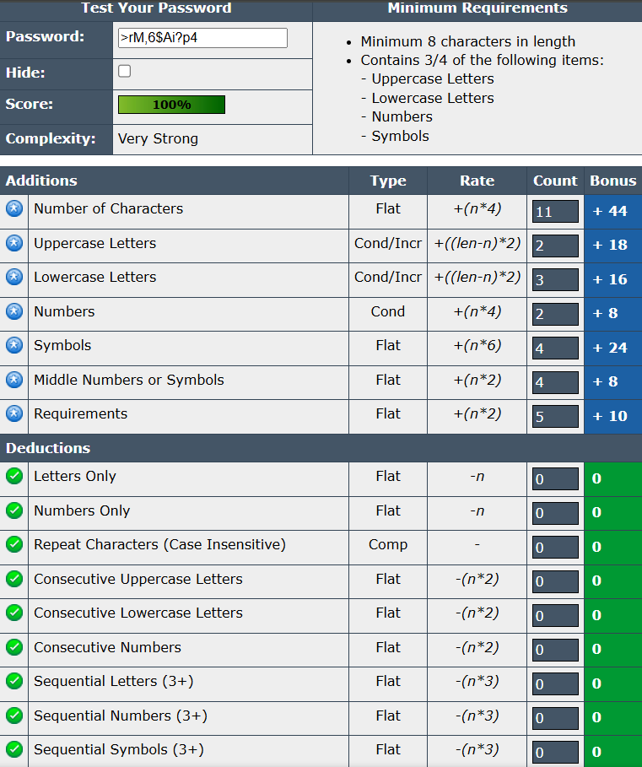

Tips learned from the evaluation:

1. **Avoid common patterns** like names followed by numbers (e.g., krish123) — they are easy to guess and vulnerable to dictionary attacks.
2. **Include a mix of uppercase, lowercase, numbers, and symbols** to increase password complexity and resistance to brute-force attacks.
3. **Longer passwords (12+ characters)** are significantly more secure, especially when combined with randomness.
4. **Avoid predictable substitutions** (e.g., @ for a, 1 for l) as attackers often account for these in their cracking tools.
5. **Use random sequences of characters** instead of meaningful words or phrases to increase entropy.
6. **Never reuse passwords** across multiple accounts; use a password manager to keep track.
7. **Update weak or old passwords regularly**, especially if any breach is suspected.

**Few Common Password Attacks:**

1. **Brute Force Attack**

* **Description**: Tries every possible combination of characters until the correct password is found.
* **Defence**: Use long, complex, and random passwords. Enable account lockout policies or CAPTCHA after several failed attempts.

1. **Dictionary Attack**

* **Description**: Uses a list of common words and phrases (a "dictionary") to guess passwords.
* **Defence**: Avoid using real words, names, or common phrases. Use a mix of character types.

1. **Phishing**

* **Description**: Trick users into giving up passwords via fake emails, websites, or messages.
* **Defence**: Always check the URL before entering credentials. Enable multi-factor authentication.

1. **Keylogging**

* **Description**: Malware records keystrokes to capture usernames and passwords.
* **Defence**: Use up-to-date antivirus software and avoid installing unknown programs.

1. **Rainbow Table Attack**

* **Description**: Uses precomputed tables of hashed passwords to reverse known hash values.
* **Defence**: Use salted hashes (random data added to passwords before hashing) and strong hashing algorithms.

Summary

Password complexity greatly enhances security by making it significantly harder for attackers to guess or crack passwords using methods like brute force or dictionary attacks. Complex passwords that include a mix of **uppercase and lowercase letters, numbers, symbols, and increased length** create a vast number of possible combinations, increasing the time and computing power needed to break them.

Key Takeaways:

* Longer and more random passwords are harder to crack.
* Including symbols and varying character types increases entropy and reduces predictability.
* Avoiding common patterns (like "123", names, or simple substitutions) prevents easy dictionary-based attacks.
* Strong passwords effectively defend against most automated and manual attack techniques.